|  |
| --- |
|  |
| EnviroSense: Environmental Sensor Platform |
| ReelyActive Subsystem User Manual |

|  |
| --- |
| RFID Application Development Lab  Breno Brezinski, Daniel Chau, Francis Agyapong, Sergio Diaz Chavez, Jediah Dizon  April 14, 2016 |

Installation and Configuration Manual

# ReelyActive System

The system that is in place sends the information via UDP protocols to the specified IP provided through the portal configuration for the hub. This portal will be available if there is a connection to the PORT 1 or PORT 2 to the PC or Server.

The information sent is specified by the script configure previously to read the information passed through the hub. This script will be running in the Server machine using node js.

**ReelyActive HUB Setup:**

The ReelyAcive HUB must be plugged in using the power supply provided by the manufacture. Once is plugged in the next step is to use the “Reelceivers” connected to the black cable coming from the HUB itself the connection has to be unidirectional that means that the “Reelceiver” has to have the Arrow pointing towards the hub. The connection of multiple “Reelceivers” it is possible in a daisy chain but **always point the arrows towards the HUB.**

**The setup should look like this. With a blinking blue light coming out from the reelceiver.**

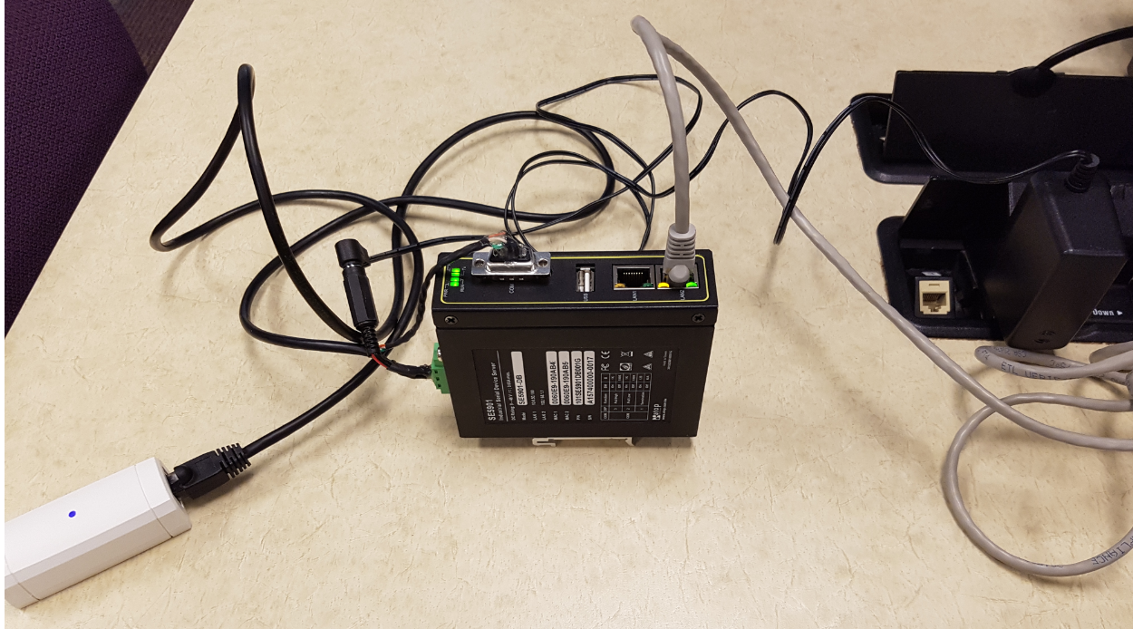

Last step is to plug one of the Ethernet ports (PORT 1 or 2) to the Server to receive the information.

# Reely Active Configuration:

Once You have your HUB installed, you can start configuring the HUB to send the packets to the Server’s IP address. In the HUB itself there are predetermine ports IP for 1 and 2, plug the Ethernet cable to one of them and type the IP of the port into a browser for this example we are using PORT2(192.168.1.1). Then you will see the HUB Authentication Page, just type “admin” and click OK.

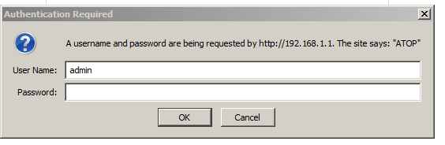

This is the portal to configure the HUB we will explain in single steps how to setup your HUB to start sending packets to the server.

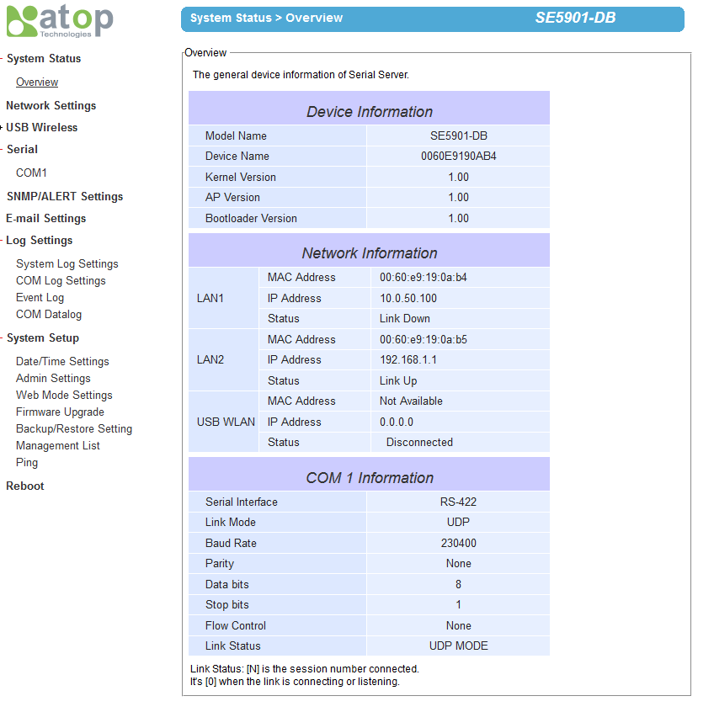

Once you enter to the configuration portal the first tab you need to go is **COM1.** This HUB it was built to transmit from serial to UDP. COM1 will be configure with the SERVER’s IP for destination 1 you should pick a port that is available for you to use and also an IP that is in the same subnet from the PORT 1 or 2.

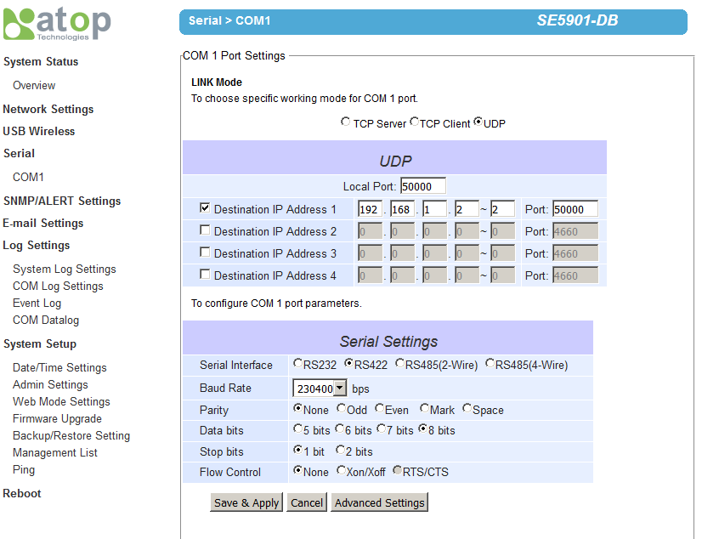

After adding the Destination IP Address 1 and the port available it is good to configure the values of the Serial Settings as it is shown in the picture.

When finalize Save & Apply, the page will refresh and the changes are done.

If one or more changes didn’t work properly you can always Factory reset to the default settings only going to the Reboot option and this page will be displayed.

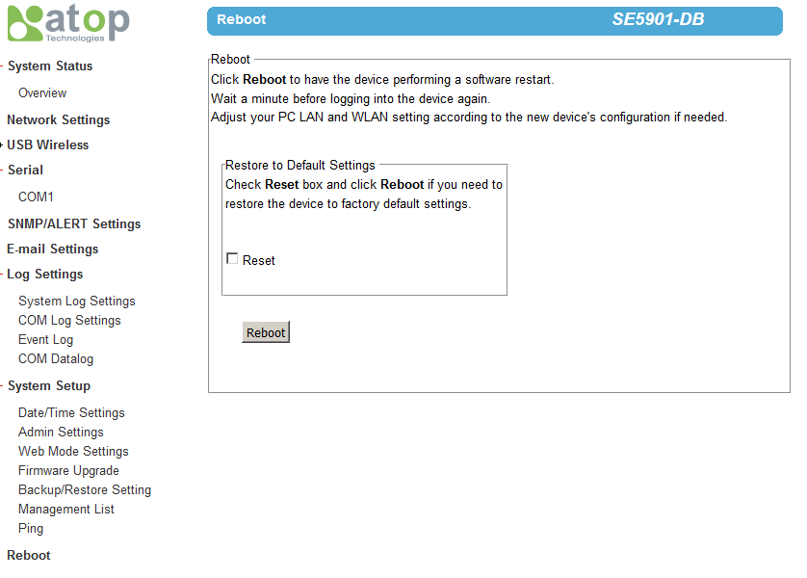

Here you can do a Reboot of the HUB or a complete Factory Reset.

# Running the script to listen to the packets

The script will be deployed along with the application to Ubuntu server. This script will be store in the /home/ directory and it will run as.